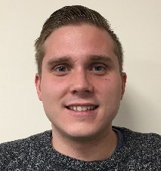
Michael Bonnichon – Manager, EMEA Regional Operations
Email: mbonnichon@aires.com
Direct Dial: +44 020 8544 8096
Based in our London office, Michael joined Aires in 2017, with nine years of client services experience. Michael is responsible for the operational performance in the EMEA region as well as managing and motivating the team and working directly with global sales and operations to ensure client engagement and retention. He also effectively manages the connection between the region and our corporate culture, goals, strategy, and vision via effective communication and collaboration.
Michael most recently served as a Mobility Specialist Team Lead and has been a two-time recipient of the Aires Circle of Excellence award for outstanding customer service. Prior to joining Aires, Michael held a position as a Key Account Manager at a Temporary Housing firm. Michael’s credentials include a bachelor’s degree. In addition to English, Michael speaks Danish.

