Peter Ferreira, CRP – Regional Operations Manager
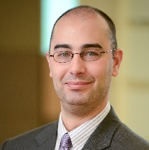
Email: pferrei@aires.com
Direct Dial: +1.214.622.6554
Peter joined Aires in 2012 with 10 years of previous relocation experience. Peter is the Operations Manager of Aires’ Phonix, AZ and Huntington Beach, CA offices. He is responsible for the day-to-day operations and oversight of Mobility Specialists and Policy & Property Consultants, ensuring customer service and service delivery standards are maintained. Peter also has oversight of new client implementations to ensure our partnerships get off to a positive start. He works directly with our Client Service Managers throughout the implementation process to keep our project plans on track for successful implementation.
In his time with Aires, Peter has been a five-time recipient of the Aires Circle of Excellence award for outstanding customer service. Peter’s experience prior to joining Aires includes roles as an Operations Manager and Relocation Consultant with a competing relocation management company and as a Technical Operations Manager with a technology company. His credentials include the Certified Relocation Professional designation from Worldwide ERC® and a bachelor’s degree in management. He speaks conversational Portuguese.

